**How Can We Make Video Games More Accessible**

**To People with Tourette Syndrome?**

**Team “1T2S” (Tourette Syndrome Support)**

**Alessandra Bettina S. Garcia**

**Neal Alden Q. Cua**

**Kyle S. Ricalde**

**Reinald Josef Kristjan B. Tomenes**

**Group 7, Grade 11-SD1, AY 2017-2018**

Submitted to the

Senior High School Department

in partial fulfillment of the requirements for the course on

Computer Programming

(Project Based Learning)

Supervised By:

Ms. Duchess Domagsang

iAcademy

December 9, 2017

Makati City, Philippines

**ABSTRACT**

Tourette syndrome (TS) is a neurological disorder characterized by repetitive, stereotyped, involuntary movements and vocalizations called tics.TS does not have a known specific cause, but it can be caused by either genetic or environmental factors.

Tics are likely to interfere when a player with TS is trying to enjoy a game, which is why the 1T2S team —a team of four—intends to make a game that people with or without Tourette’s, can play with ease and enjoy to the fullest. It is not meant to be therapeutic, but because Tourette’s does not have a single universal cure, it could reduce one’s tics, depending on the person.

The game features single-button commands and a back feature, which allows the player to read back on text they may have skipped accidentally. This will be very useful and convenient to those with Tourette’s, especially those who have motor tics that may have something to do with the keyboard, or perhaps tics that prevent them from pressing keys for too long.

The team aims to make the game entertaining for everyone, whether the player is a gamer or not. Therefore, after creating a very early demo of the game, the team contacted potential playtesters that have TS and those that do not. The results show that although the game is still unfinished and needs fixing, it still shows potential, and the team might be able to

**ACKNOWLEDGEMENTS**

This Project Based Learning output becomes a reality with the kind support and help of many individuals; we would like to extend our sincerest thanks to all of them.

First, we want to offer this group endeavor to our GOD Almighty for the wisdom he bestowed upon each one of us, the physical strength to work on long hours, peace and clarity of mind, patience with each other and good health in order to finish this research.

We would like to express our gratitude towards each of our family most especially to our parents, for their unending support and encouragement to complete this paper.

We appreciate the kind and generous help of all our teachers most especially to Ms. Duchess Domagsang who served as our guide as we implement the plans we have set out in the beginning. We would have never known that such medical condition ever existed if not for the lessons of Ms. Mara Concepcion Luarte on Tourette Syndrome and for this we are grateful to her.

Lastly, we are indebted to the Philippine Tourette Syndrome Association through its President, Mr. Marlon Barnuevo, for their support in research work to include the play testing session. The time we spent with them allowed us to probe deeper in their daily lives and how it has been greatly affected by Tourette Syndrome. The interaction with their members did not only help us understand better their medical condition but it has also inspired us to become an advocate for them. Without their valuable time spent with us, the output we have made will not come into fruition.

**TABLE OF CONTENTS**

Page

Abstract ……………………………………………………... 1

Acknowledgements …………………………………………. 2

Table of Contents ……………………………………………. 3

CHAPTER

1. INTRODUCTION ……………………………….……….. 7

1.1 PURPOSE ……………………………………….. 8

2. TOURETTE SYNDROME

2.1 Nature and classification of the condition………… 9-12

2.2Organs and Organ Systems affected ……………… 12- 13

2.3 Treatment and/Management of the condition ………. 14-15

2.4 Current Technologies that can be used ………………..15-17

3. PROJECT DESCRIPTION ……………………………………. 18-20

4. PROJECT STRUCTURE ……………………………………… 21-38

5. CONCLUSIONS ……………………………………………… 39-45

APPENDICES ………………………………………………………………. 46-54

1. Appendix A - Evaluation Instruments for Users (with Tourette Syndrome)

2. Appendix B - Evaluation Instruments for Users (without Tourette Syndrome)

3. Appendix C - Evaluation Instruments for IT Experts (without Tourette Syndrome)

BIBLIOGRAPHY/REFERENCES …………………………………………. 55-56

**LIST OF TABLES**

Table 5-1. Responses of Playtesters with Tourette Syndrome

Table 5-2. Responses of Playtesters without Tourette Syndrome

Table 5-3. Responses of Playtesters without Tourette Syndrome and Are IT Experts

**LIST OF ILLUSTRATIONS**

Illustration 5-1. Age Groups the Playtesters With Tourette Syndrome Belong In

Illustration 5-2. Age Groups the Playtesters Without Tourette Syndrome Belong In

C**HAPTER 1**

**INTRODUCTION**

Through the development of this game, the team can show the video game industry that there’s still more that can and should be done to make games accessible to all people, regardless of their disability, and especially to those with motor disabilities. Motor disabilities can prevent many players from playing most games as this can lead to unintentional inputs, so the team wants to show that there are creative and even simple ways to work around this problem.

Currently, other game developers are working on making games more accessible to disabled players. They do this by adding various options such as bigger subtitles, and many different visual, and auditory cues to their games. Though this is for a broader spectrum of disabilities, the goal of the team is to make sure games are more accessible to those with Tourette’s. Notably, there has been a game that can help with the team’s research. Lars Doucet is a game designer with Tourette’s and he designed a game called “Tourette’s Quest”. It’s a game designed to allow people without Tourette’s to experience how having Tourette’s feels like through its game play. This can be used to further understand the team’s target demographic, and help design their game to be less stressful for those with Tourette’s to control.

Even with the industry’s efforts to make games more accessible to those with disabilities, most AAA games aren’t that accessible to players with more complex disabilities. Though deaf and blind players can join in on the fun with recent advancements in technology such as motion control games, people with motor disabilities, such as Tourette’s, still can’t play most games as easily as people without disabilities can.

**1.1 PURPOSE**

The thesis is about a game being developed by the team of four game developers to show the video game industry how to make games more accessible to people with disabilities. The game, titled “**The Solemn Reign**”, specifically targets a demographic of people with *Tourette Syndrome*, or as it is more commonly referred to, *Tourette’s*.

**CHAPTER 2**

**TOURETTE SYNDROME**

**3.1Nature and Classification of the Condition**

Tourette syndrome (TS) is a neurological disorder characterized by repetitive, stereotyped, involuntary movements and vocalizations called tics. The disorder is named for *Dr. Georges Gilles de la Tourette*, the pioneering French neurologist who in 1885 first described the condition in an 86-year-old French noblewoman.

Tourette Syndrome is a developmental neuropsychiatric disorder of childhood onset. There is no diagnostic test for this disorder. TS occurs in people from all ethnic groups; males are affected about three to four times more often than females. It is estimated that 200,000 Americans have the most severe form of TS, and as many as one in 100 exhibit milder and less complex symptoms such as chronic motor or vocal tics. Although TS can be a chronic condition with symptoms lasting a lifetime, most people with the condition experience their worst tic symptoms in their early teens, with improvement occurring in the late teens and continuing into adulthood.

Although the cause of TS is unknown, current research points to abnormalities in certain brain regions (including the basal ganglia, frontal lobes, and cortex), the circuits that interconnect these regions, and the neurotransmitters (dopamine, serotonin, and norepinephrine) responsible for communication among nerve cells. Given the often complex presentation of TS, the cause of the disorder is likely to be equally complex.

Tourette Syndrome is a diagnosis that doctors make after verifying that the patient has had both motor and vocal tics for at least 1 year.  The existence of other neurological or psychiatric conditions can also help doctors arrive at a diagnosis.  Common tics are not often misdiagnosed by knowledgeable clinicians.  However, atypical symptoms or atypical presentations (for example, onset of symptoms in adulthood) may require specific specialty expertise for diagnosis. There are no blood, laboratory, or imaging

tests needed for diagnosis.  In rare cases, neuro-imaging studies, such as magnetic resonance imaging (MRI) or computerized tomography (CT), electroencephalogram (EEG) studies, or certain blood tests may be used to rule out other conditions that might be confused with TS when the history or clinical examination is atypical.

It is not uncommon for patients to obtain a formal diagnosis of TS only after symptoms have been present for some time. The reasons for this are many.  For families and physicians unfamiliar with TS, mild and even moderate tic symptoms may be considered inconsequential, part of a developmental phase, or the result of another condition.  For example, parents may think that eye blinking is related to vision problems or that sniffing is related to seasonal allergies.  Many patients are self-diagnosed after they, their parents, other relatives, or friends read or hear about TS from others.

According to Diagnostic and Statistical Manual, Fourth Edition, Text Revision (DSM-IVTR), it is characterized by brief, stereotypical but non-rhythmic “jerky” movements and vocalizations called tics. Tics are classified as either simple or complex. Simple motor tics are sudden, brief, repetitive movements that involve a limited number of muscle groups. Some of the more common simple tics include eye blinking and other eye movements, facial grimacing, shoulder shrugging, and head or shoulder jerking.  Simple vocalizations might include repetitive throat-clearing, sniffing, or grunting sounds. Complex tics are distinct, coordinated patterns of movements involving several muscle groups. Complex motor tics might include facial grimacing combined with a head twist and a shoulder shrug. Other complex motor tics may actually appear purposeful, including sniffing or touching objects, hopping, jumping, bending, or twisting. Simple vocal tics may include throat-clearing, sniffing/snorting, grunting, or barking. More complex vocal tics include words or phrases.

Perhaps the most dramatic and disabling tics include motor movements that result in self-harm such as punching oneself in the face or vocal tics including coprolalia (uttering socially inappropriate words such as swearing) or echolalia (repeating the words or phrases of others).   However, coprolalia is only present in a small number (10 to 15 percent) of individuals with TS. Some tics are preceded by an urge or

sensation in the affected muscle group, commonly called a premonitory urge. Some with TS will describe a need to complete a tic in a certain way or a certain number of times in order to relieve the urge or decrease the sensation.

Tics are often worse with excitement or anxiety and better during calm, focused activities. Certain physical experiences can trigger or worsen tics, for example tight collars may trigger neck tics, or hearing another person sniff or throat-clear may trigger similar sounds. Tics do not go away during sleep but are often significantly diminished.

In the natural history of TS, motor tics often begin between the age of 3 and 8, several years before the appearance of vocal tics. Tics come and go over time, varying in type, frequency, location, and severity.  The first symptoms usually occur in the head and neck area and may progress to include muscles of the trunk and extremities. Motor tics generally precede the development of vocal tics and simple tics often precede complex tics.  Most patients experience peak tic severity before the mid-teen years with improvement for the majority of patients in the late teen years and early adulthood. Approximately 10-15 percent of those affected have a progressive or disabling course that lasts into adulthood.

Another feature of tics is that they are frequently associated with antecedent sensory phenomena, so-called premonitory urges, such as an impulse to scratch an itchy patch of skin. Such urges are experienced as nearly irresistible and occasionally painful, and in some individuals with TS, they are a major source of mental impairment.[9](https://www.ncbi.nlm.nih.gov/pmc/articles/PMC3000195/#B9) There may also be sensory cues, which prompt tics of a particular sort (e.g., a cough or a word), suggesting that specific motor patterns or habits are activated by specific sensory pathways.[10](https://www.ncbi.nlm.nih.gov/pmc/articles/PMC3000195/#B10) A momentary sense of physical relief or a generalized abatement of inner tension often follows performance of a tic, suggesting the involvement of reward neuro-circuitry.

Tics often occur in discrete bouts over time scales of days to years,[14](https://www.ncbi.nlm.nih.gov/pmc/articles/PMC3000195/#B14) but these patterns have yet to be usefully modeled to predict either outcome or treatment response. The bouts are characterized by brief periods of stable inter-tic intervals of short duration,

typically 0.5 to 1.0 second, and inter-bout intervals that may last from minutes to hours over the course of a day. Understanding the upstream processes that govern the timing of tic expression ultimately may clarify both neural events occurring in millisecond time scales as well as the natural history of tic disorders that occurs over the first two decades of life.

The description of tics as simply intermittent trains of completely involuntary motor discharge is incomplete. Indeed, many tics are often under partial voluntary control, evidenced by patients' capacity to suppress them for brief periods of time, subject to many factors including everyday stress, anxiety, and emotion.

Although the symptoms of TS are involuntary, some people can sometimes suppress, camouflage, or otherwise manage their tics in an effort to minimize their impact on functioning. However, people with TS often report a substantial buildup in tension when suppressing their tics to the point where they feel that the tic must be expressed (against their will). Tics in response to an environmental trigger can appear to be voluntary or purposeful but are not.

Tics may be thought of as part of a spectrum of partially voluntary behaviors that include compulsions, substance abuse, pathological gambling, and perhaps even our daily personal and interpersonal habits. Interestingly, activities that require focused attention and fine motor control, such as reading aloud, playing a musical instrument, engaging in certain sports, and even performing surgery, are associated with transient improvements in tics. Finally, although much diminished, tics can sometimes occur during sleep, distinguishing them from many other movement disorders. Indeed, polysomnographic studies indicate that sleep disturbance is also part of the TS picture, with decreased quality and increased arousal phenomena.Associated co-morbidities are also likely to contribute to sleeping difficulties.

Many individuals with Tourette Syndrome experience additional neurobehavioral problems that often cause more impairment than the tics themselves.  These include inattention, hyperactivity and impulsivity (attention deficit hyperactivity disorder—ADHD);problems with reading, writing, and arithmetic; and obsessive-compulsive

symptoms such as intrusive thoughts/worries and repetitive behaviors. For example, worries about dirt and germs may be associated with repetitive hand-washing, and concerns about bad things happening may be associated with ritualistic behaviors such as counting, repeating, or ordering and arranging.

People with Tourette Syndrome have also reported problems with depression or anxiety disorders, as well as other difficulties with living, that may or may not be directly related to TS.  In addition, although most individuals with TS experience a significant decline in motor and vocal tics in late adolescence and early adulthood, the associated neurobehavioral conditions may persist.  Given the range of potential complications, people with TS are best served by receiving medical care that provides a comprehensive treatment plan.

Although there is no cure for TS, the condition in many individuals improves in the late teens and early 20s. As a result, some may actually become symptom-free or no longer need medication for tic suppression. Although the disorder is generally lifelong and chronic, it is not a degenerative condition. Individuals with TS have a normal life expectancy. TS does not impair intelligence. Although tic symptoms tend to decrease with age, it is possible that neurobehavioral disorders such as ADHD, OCD, depression, generalized anxiety, panic attacks, and mood swings can persist and cause impairment in adult life.

**2.2 Organs and Organ Systems being affected by the Condition**

The neurologic system is the main body system targeted by Tourette Syndrome. The autonomic nervous system specifically is affected with its central influences on tic activity.  The central neural mechanisms of tic generation are not clearly understood, however recent neuro-imaging investigations suggest impaired cortico-striato-thalamo-cortical activity during motor control. There is emerging evidence that both sympathetic and parasympathetic nervous activity influences tic expression.

**2.3 Treatment and/or Management of the Condition**

Because tic symptoms often do not cause impairment, the majority of people with TS require no medication for tic suppression. However, effective medications are available for those whose symptoms interfere with functioning. Neuroleptics (drugs that may be used to treat psychotic and non-psychotic disorders) are the most consistently useful medications for tic suppression; a number are available, but some are more effective than others (for example, haloperidol and pimozide).

Unfortunately, there is no one medication that is helpful to all people with TS, nor does any medication completelyeliminate symptoms.  In addition, all medications have side effects. Many neuroleptic side effects can be managed by initiating treatment slowly and reducing the dose when side effects occur. The most common side effects of neuroleptics include sedation, weight gain, and cognitive dulling.  Neurological side effects such as tremor, dystonic reactions (twisting movements or postures), parkinsonian-like symptoms, and other dyskinetic (involuntary) movements are less common and are readily managed with dose reduction.

Discontinuing neuroleptics after long-term use must be done slowly to avoid rebound increases in tics and withdrawal dyskinesias. One form of dyskinesia called tardive dyskinesia is a movement disorder distinct from TS that may result from the chronic use of neuroleptics. The risk of this side effect can be reduced by using lower doses of neuroleptics for shorter periods of time.

Other medications may also be useful for reducing tic severity, but most have not been as extensively studied or shown to be as consistently useful as neuroleptics.  Additional medications with demonstrated efficacy include alpha-adrenergic agonists such as clonidine and guanfacine.  These medications are used primarily for hypertension but are also used in the treatment of tics. The most common side effect from these medications that precludes their use is sedation. However, given the lower side effect risk associated with these medications, they are often used as first-line agents before proceeding to treatment with neuroleptics.

Effective medications are also available to treat some of the associated neurobehavioral disorders that can occur in patients with TS.  Recent research shows that stimulant medications such as methylphenidate and dextroamphetamine can lessen ADHD symptoms in people with TS without causing tics to become more severe.  However, the product labeling for stimulants currently contraindicates the use of these drugs in children with tics/TS and those with a family history of tics. Scientists hope that future studies will include a thorough discussion of the risks and benefits of stimulants in those with TS or a family history of TS and will clarify this issue.  For obsessive-compulsive symptoms that significantly disrupt daily functioning, the serotonin reuptake inhibitors (clomipramine, fluoxetine, fluvoxamine, paroxetine, and sertraline) have been proven effective in some patients.

Behavioral treatments such as awareness training and competing response training can also be used to reduce tics.  A recent NIH-funded, multi-center randomized control trial called Cognitive Behavioral Intervention for Tics, or CBIT, showed that training to voluntarily move in response to a premonitory urge can reduce tic symptoms.   Other behavioral therapies, such as biofeedback or supportive therapy, have not been shown to reduce tic symptoms.  However, supportive therapy can help a person with TS better cope with the disorder and deal with the secondary social and emotional problems that sometimes occur.

**2.4 Current Technologies that can be used by the Individual**

The study, which has been published in the British Psychological Society's Journal of Neuropsychology, could herald new non-drug therapies to help young people with TS overcome the repetitive physical movements and vocal sounds which characterize their condition. In the current study, the team used a method called Transcranial Magnetic Stimulation (TMS) in which a magnetic field is passed over the brain to produce a weak electrical current which stimulates motor function to induce a twitch response. By delivering TMS at different points in time as participants were about to undertake a hand movement, the researchers were able to measure alterations in brain excitability ahead of the movement and chart the differences between each person.

Further research by the team has involved the use of a similar type of brain stimulation called Transcranial Direct Current Stimulation (TDCS) to study the brains of children with TS. Early results suggest that TDS can be applied to decrease neuronal excitability, and this may be effective in suppressing tics for extended periods. In addition, if another form of TDCS is applied, one that increases neuronal excitability, it may act to improve learning and memory function, particularly in the context of behavioral therapies. Following use of these treatments lasting effects can be applied to the brain.

If proven to be effective, the technology could be adapted into a TENS machine-style device that would offer a cheap, portable and individualized therapy for children with TS. "It can be applied at home while the child is watching TV or eating their cornflakes so it would reduce the amount of school they would miss and potentially we can use the TDCS to both control the tics and make that control more effective and longer lasting."

Others with good scientific evidence include the 5-HTP or 5-hydroxytryptophan is a naturally occurring amino acid in the body that helps make the neurotransmitter (brain chemical) serotonin. Cerebellar ataxia results from the failure of part of the brain to regulate body posture and limb movements. 5-HTP has been observed to have benefits in some people who have difficulty standing or walking because of cerebellar ataxia. Some research shows that 5-HTP may allow individuals with unsteady movements to stand alone without assistance, walk without aid, or improve coordination. 5-HTP may interact with other mood-altering medications such as antidepressants and anti-anxiety drugs.

Music therapy has been reported to improve symptoms in people with Parkinson's disease. Modest improvements were seen in symptoms including: motor coordination, speech intelligibility and vocal intensity, bradykinesia (slow movement), emotional functions, activities of daily living, and quality of life.

One treatment that could hold potential is Valbenazine, an experimental drug made by Neurocrine Biosciences. The drug inhibits a protein called VMAT2, which is concentrated in the human brain and modulates the release of dopamine during neural communication. The drug is also being investigated for tardive dyskinesia, a disorder characterized by twitching of the face and jaw for which there is currently no treatment. Neurocrine received a Breakthrough Therapy Designation for this indication, and has already submitted a New Drug Application (NDA).

Another promising contender is Sativex, GW Pharma’s cannabinoid spray, which affects the dopamine system in a slightly different way. In August, Evans and colleagues published a case report in the journal Australasian Psychiatry. They found that Sativex was safe and effective for mitigating TS symptoms in a previously treatment-resistant patient.

Based on these findings, the team applied for a special license to treat with Sativex, which is available as an oromucosal spray. The subject received two metered doses of spray daily, each containing 2.7mg of tetrahydrocannabinol (THC) and 2.5mg of Cannabidiol (CBD). Having measured tics pre- and post-treatment, the team noted a considerable improvement: motor tics were reduced by 85% and vocal tics by 90%. This was reflected in the subject’s quality of life and performance in his day-to-day undertakings.  Because it is still unclear whether THC, other active cannabinoids, or the ratio between the different cannabinoids, provides the best anti-tic effect, the researchers subsequently trialed the subject on CBD alone. However, results were similar to no treatment and significantly worse than on Sativex.

According to a 2015 study, published in the journal Trends in Cognitive Sciences, the neurotransmitter gamma-aminobutyric acid (GABA) may also be a useful place to concentrate research efforts. The University of Nottingham researchers reviewed evidence suggesting that reduced GABA levels can lead to the overexcitement of nerve cells, causing tics. They found that an increase in GABA levels – rather than greater self-control, for example – may be responsible for the classic alleviation in symptoms as patients go through adolescence. This could lead to therapies that mimic the effects of GABA, i.e. by blocking nerve transmission in areas responsible for motor function.

**CHAPTER 3**

**PROJECT DESCRIPTION**

The game is being developed by the team of four game developers to show the video game industry how to make games more accessible to people with disabilities. The game, titled “**The Solemn Reign**”, specifically targets a demographic of people with *Tourette Syndrome*, or as it is more commonly referred to, *Tourette’s*. The team intends to make a game that people with or without Tourette’s, can play with ease and enjoy to the fullest. It is not meant to be therapeutic, but because Tourette’s does not have a single universal cure, it could reduce one’s tics, depending on the person.

The team aims to make the game entertaining for everyone, whether the player is a gamer or not.The team used the GDevelopIDE in making “**The Solemn Reign**”, andit can be played on computers that run on Windows.

**3.1 General Description of UI**

GUI:

a. Clock - shows the time.

b. Current quest - shows current task.

c. Current location - shows up when going in different locations.

d. Inventory - shows the items the player has.

e. On-screen Commands - images that show the buttons the player can press.

f. Pause Menu

* 1. Save -saves the game.
  2. Load - loads a save file.

g. Controls - shows commands the player can use, but aren’t always on-screen. Quit - exit the current game. Back - go back to the game. 7. Dialogue Box - shows dialogue and narration. 8. Character Icons - shows which characters are talking or being talked about.

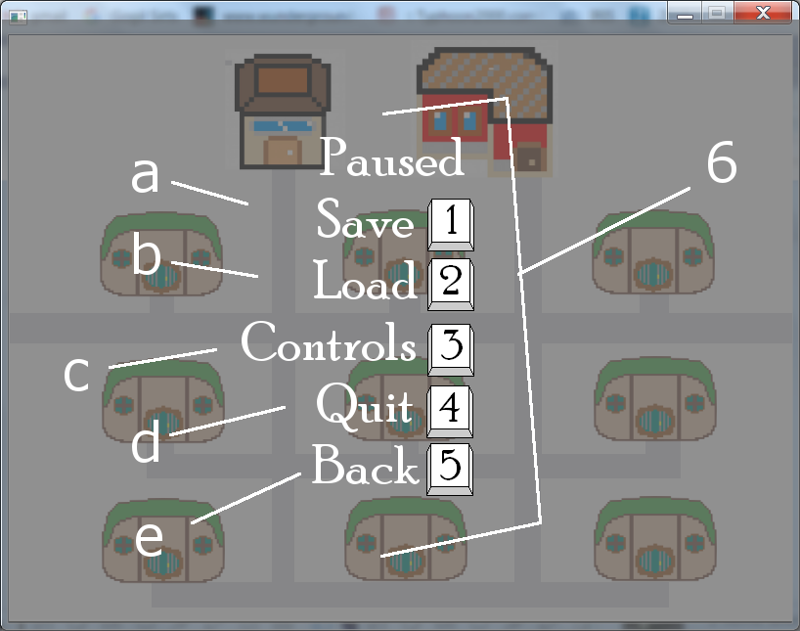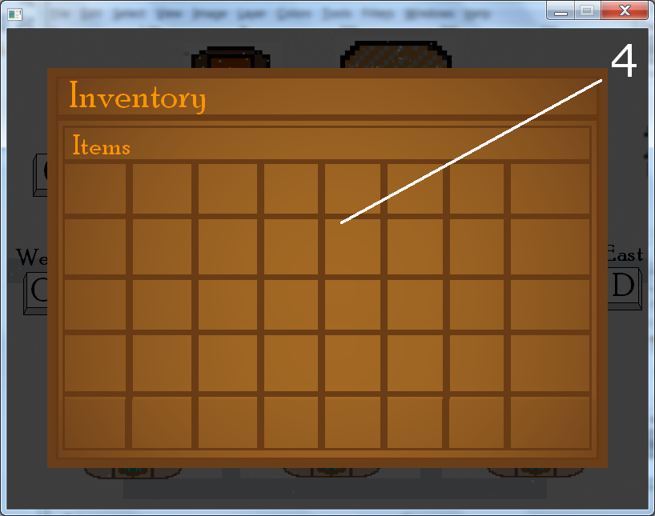

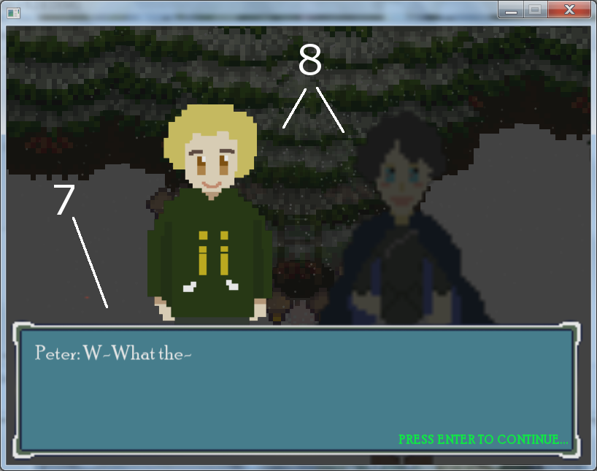

**CHAPTER 4**

**PROJECT STRUCTURE**

**4.1 Algorithms Used**

**Algorithms:**

1. **Dialogue System**
2. If the player is interacting with an entity in the game or an entity in the game interacts with the player, show the text box and dialogue.
3. If a character needs to be displayed on screen then load the correct sprite into Character 1 or Character 2 based on who they are. **Note: Character 1 is reserved for MC unless two NPCs are talking to each other. All NPCs default to Character 2 unless they are talking to another NPC.**
4. If a character is not supposed to be displayed on screen then load an empty sprite into Character 1 or Character 2 depending on where the character was.
5. If MC or BF moves to a new location then change the background to the appropriate location.
6. Show the first dialogue on screen inside the textbox.
7. Check if the conditions for Step 2-4 are true or false. Then do their corresponding actions if their respective condition is true.
8. If the player presses enter then load the next line/s of dialogue.
9. If the player presses backspace then load the previous line/s of dialogue. **Note: Backspace is disabled for the first line/s of dialogue.**
10. Repeat steps 6-8 until the system runs out of dialogue.
11. If the system runs out of dialogue then hide the text box, dialogue and characters.
12. If MC has to be in a new location then set the variable “playerLocation” to the new location.
13. **Location System**
14. If a new game is started then set the player’s location to “A”.
15. If a save file is loaded then set the player’s location to the saved variable of “playerLocation” in the save file.
16. If the player’s location is set/changed then set the background’s animation to the corresponding animation. Ex. If LocationID equals “A” then AnimID equals 0.
17. Enable/Disable the player’s single-button commands to the corresponding buttons shown on screen.
18. If the player presses one of the single-button commands that represent moving to a new location then set the player’s location to the corresponding LocationID stored inside of playerLocation.
19. Repeat step 3 for every change of location.
20. **Day/Night System**
21. If the player is already in game and the game is not paused then add 0.28 to the variable Time as long as the player is still in game and the game is not paused.
22. If the time accumulates to 1440 or more then add 1 to the day counter and begin to minus 0.28 to the variable Time as long as the player is still in game and the game is not paused.
23. If Time is less than 1020 then set Time to 360.
24. Set the opacity of “Darkness” to Time divided by 15**.**
25. **Save System**
    1. **From Main Menu**
26. If the player selects a slot to start a new game then set the variable “saving” to 1.
27. If “saving” equals 1 then write the following list of data to file “Slot[Slot Number]”and then set the variable saving to 0.
28. Player Name
29. Player Gender
30. BF Name
31. BF Gender
32. Player Location
33. Sub Location
34. Current Slot
35. Day
36. Time
37. Past Midnight
38. Time Fade
39. Visited Ian
40. Talked to Rose
41. AH Drawer Opened
42. AH Cupboard Opened
43. East Puzzle
44. Museum Puzzle
45. Burning Page Puzzle
46. Book Chase Puzzle
47. InvItem1
48. InvItem2
49. InvItem3
50. InvItem4
51. InvItem5
52. InvItem6
53. InvItem7
54. Play Intro
    1. **From In-Game**
55. If the player selects a save slot from the pause menu then set the variable “saving” to 1.
56. If “saving” equals 1 then write the following list of data to file “Slot[Slot Number]”and then set the variable saving to 0.
57. Player Name
58. Player Gender
59. BF Name
60. BF Gender
61. Player Location
62. Sub Location
63. Current Slot
64. Day
65. Time
66. Past Midnight
67. Time Fade
68. Visited Ian
69. Talked to Rose
70. AH Drawer Opened
71. AH Cupboard Opened
72. East Puzzle
73. Museum Puzzle
74. Burning Page Puzzle
75. Book Chase Puzzle
76. InvItem1
77. InvItem2
78. InvItem3
79. InvItem4
80. InvItem5
81. InvItem6
82. InvItem7
83. Play Intro
84. **Load System**
    1. **From Main Menu**
85. If the player selects a slot to load an old game then set the variable “loading” to 1.
86. If “loading” equals 1 then read the following list of data from the file “Slot[Slot Number]”and then set the variable loading to 0.
87. Player Name
88. Player Gender
89. BF Name
90. BF Gender
91. Player Location
92. Sub Location
93. Current Slot
94. Day
95. Time
96. Past Midnight
97. Time Fade
98. Visited Ian
99. Talked to Rose
100. AH Drawer Opened
101. AH Cupboard Opened
102. East Puzzle
103. Museum Puzzle
104. Burning Page Puzzle
105. Book Chase Puzzle
106. InvItem1
107. InvItem2
108. InvItem3
109. InvItem4
110. InvItem5
111. InvItem6
112. InvItem7
113. Play Intro
     1. **From In-Game**
114. If the player selects a save slot from the pause menu then set the variable “loading” to 1.
115. If “loading” equals 1 then read the following list of data from the file “Slot[Slot Number]”and then set the variable loading to 0.
116. Player Name
117. Player Gender
118. BF Name
119. BF Gender
120. Player Location
121. Sub Location
122. Current Slot
123. Day
124. Time
125. Past Midnight
126. Time Fade
127. Visited Ian
128. Talked to Rose
129. AH Drawer Opened
130. AH Cupboard Opened
131. East Puzzle
132. Museum Puzzle
133. Burning Page Puzzle
134. Book Chase Puzzle
135. InvItem1
136. InvItem2
137. InvItem3
138. InvItem4
139. InvItem5
140. InvItem6
141. InvItem7
142. Play Intro
143. **Inventory System**
     1. **Getting Items**
144. If the player receives/finds an item/s then the item’s/’ ID is stored inside the variable “currentItem”. Ex. MC has found a hidden key. The item’s ID is 50. So, currentItem is now equal to 50.
     1. **Item Sorter**
145. If currentItem does not equal 0 then check if the first slot of the inventory is empty.
146. If it is, then assign the ItemID stored in currentItem to the corresponding InvItem object of the item slot.
147. Set currentItem to 0.
148. If the first/current slot is not empty, then check if the next slot is empty.
149. Repeat step 4 until an empty slot is found.
150. If an empty slot is found do steps 2-3.
151. **Pause Menu**
152. If the “P” button is pressed then disable all controls.
153. Show the object “DialogueBlinds” to dim the background.
154. Show the pause menu.
155. Enable the single-button commands that correspond to the pause menu.
156. If the “1” button is pressed then show the save slots for the player to chose a file to save to.
157. If the “2” button is pressed then show the save slots for the player to chose a file to load.
158. If the “3” button is pressed then display the game’s controls.
159. If the “4” button is pressed then ask the player if they really want to quit.
160. If the player doesn’t respond within 5 seconds then unpause the game and enable all disabled controls.
161. If the “5” button is pressed then unpause the game and enable all disabled controls.
162. If any of the buttons 1-5 are pressed then display a back button that is controlled by pressing number 2 near the bottom of the screen.
163. If the “2” button is pressed while the save slots, load slots, or controls are displayed on the screen then go back to the pause menu.

**4-2. Project Capabilities and Limitations**

**A. Capabilities**

* The game is not only relaxing, but also immersive and engaging, which invites the player to focus on it. This is good for those with TS, as less stress means less tics, and some of them would have less tics than they usually do or none at all if all their attention is on something else.
* The single-button commands make interactions very easy for those with TS.

**B. Limitations**

* The team had difficulties finding people with TS that belong in their age group, which would be teenage years. The team’s target audience is people of the same age as them, which means that it might be hard to reach them when our game is finally out, or at least has much more progress.
* The game’s main menu is complicated to code, which is why it takes the longest to implement.
* The given time for the project is too short for the team to be able to complete their game, thus it remains unfinished.
* Some people with TS might not be able to play our game, depending on the severity of their condition. Others might think of games as something that would stress them, which is why they might avoid playing them in general.

**4-3. Screenshots**

TITLE SCREEN

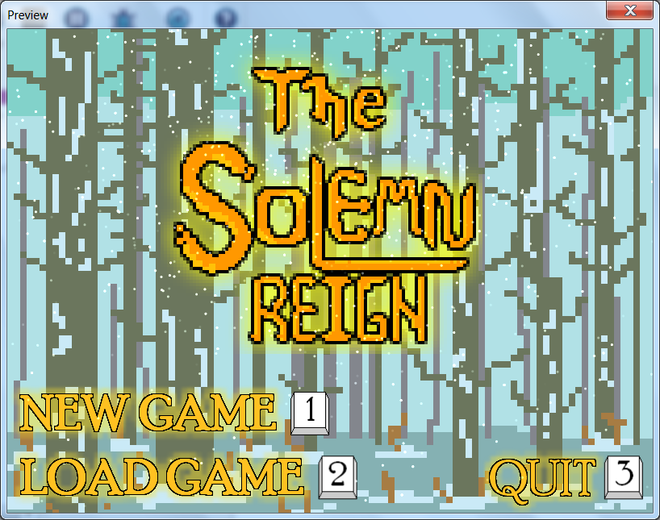

**4-3. Screenshots**

EASTERN FOREST

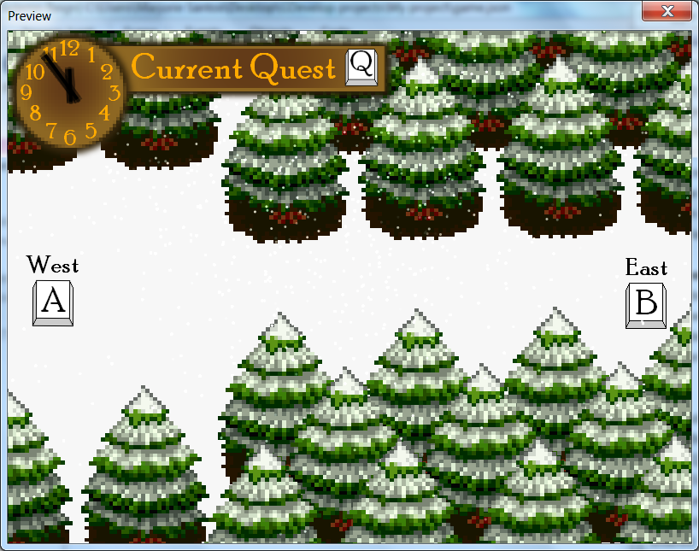

WOODCUTTER’S CABIN

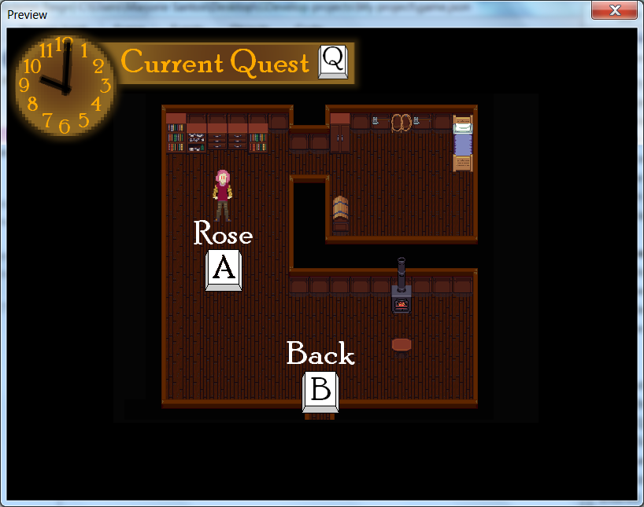

**4-3. Screenshots**

ABANDONED HOUSE

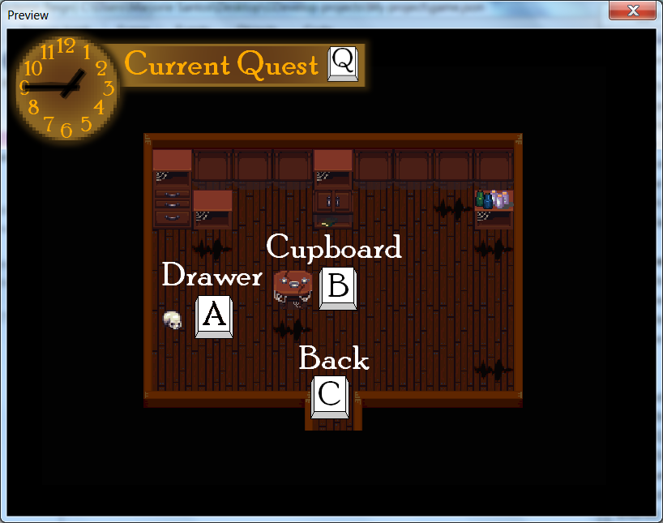

INTRO SCENE

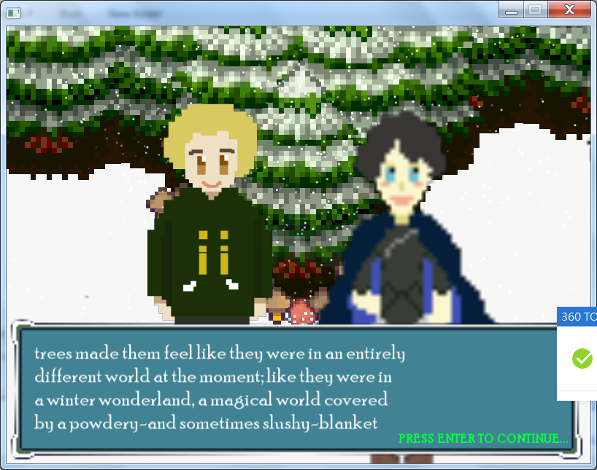

**4-3. Screenshots**

END OF DEMO SCENE

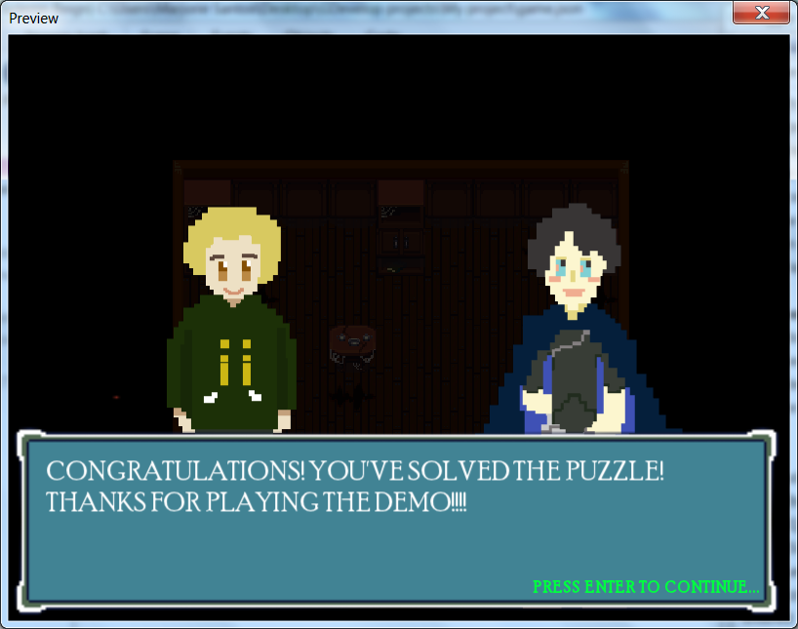

OUTSIDE THE ABANDONED HOUSE

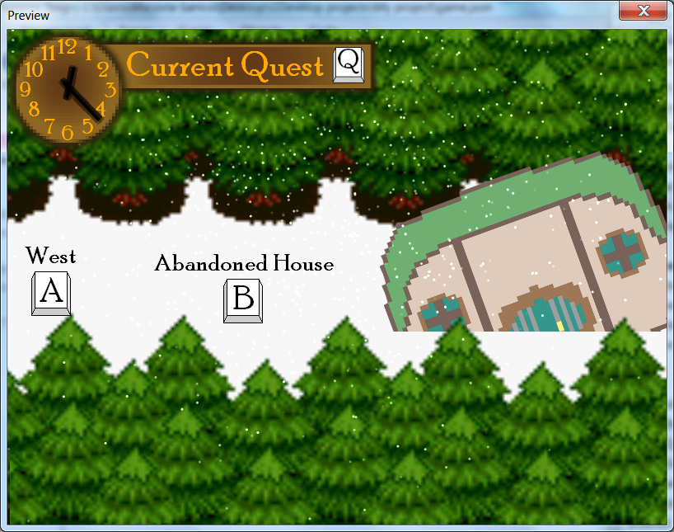

**4-3. Screenshots**

EASTERN VILLAGE

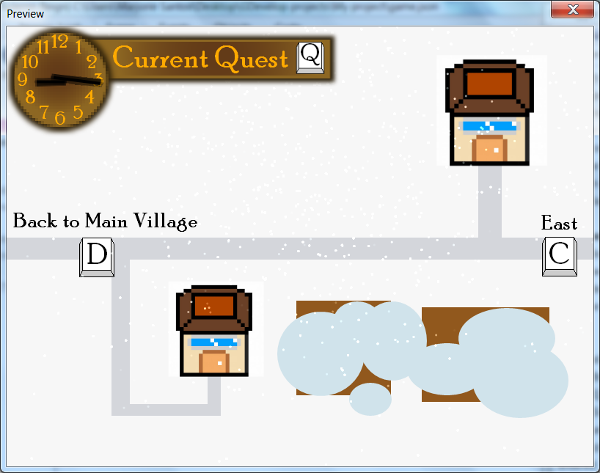

**4-4. Code Snippets**

1. **Dialogue System –** Allows the game’s dialogue and cutscenes to function properly. This system also allows the player to move forwards or backwards through the dialogue/narration of the game.

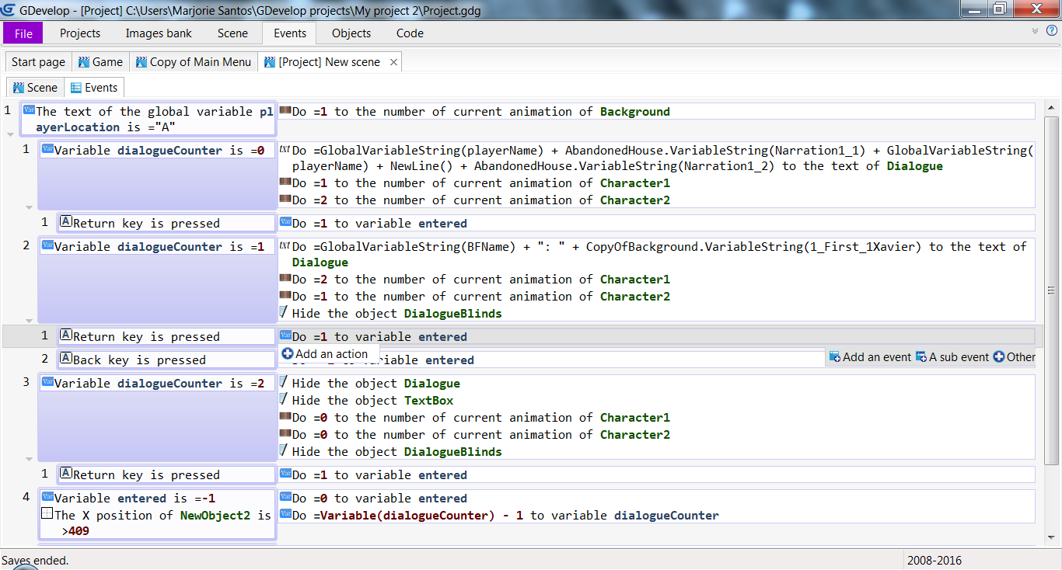

1. **Location System –** Used to track and set the player’s location. It is also used to change the background’s animation and show or hide the correct art assets based on the player’s location.

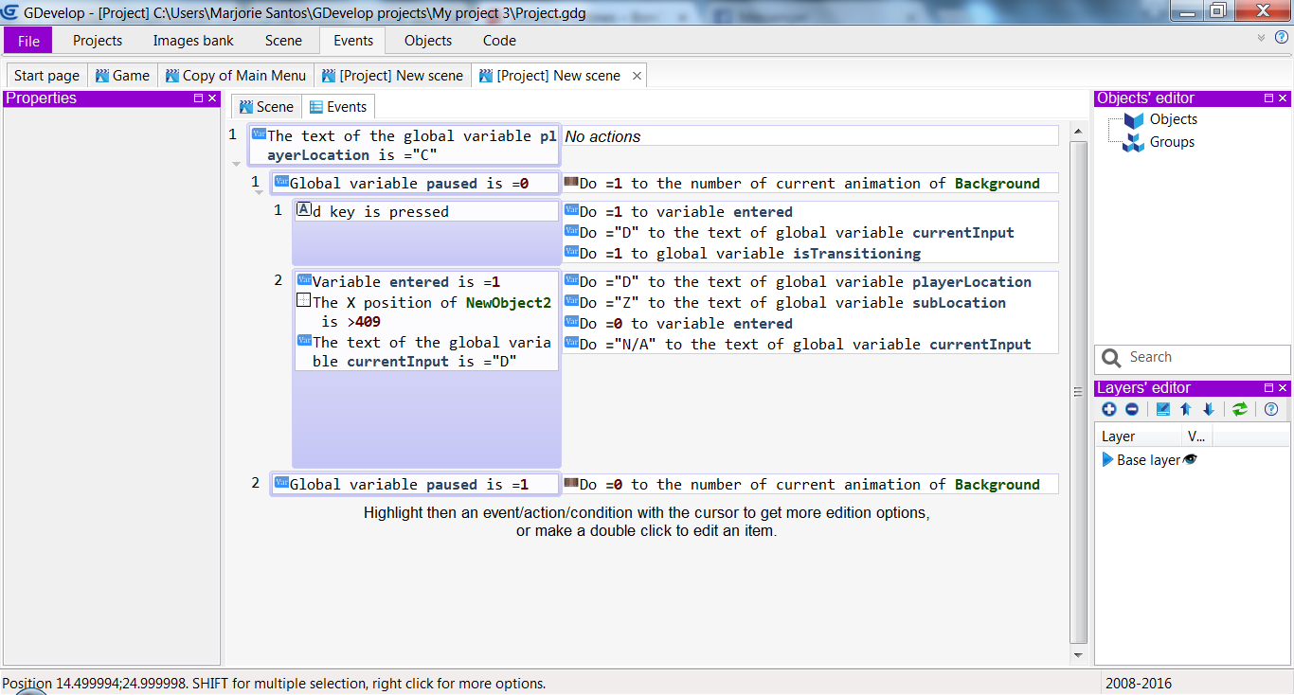

**CHAPTER 5**

**CONCLUSIONS**

**5.1 Summary of Findings**

**Table 5-1. Responses of Playtesters with Tourette Syndrome**

Rating Scale: 5=Excellent, 4 = Very Good, 3 = Good, 2 = Fair, 1 =Poor

|  |  |  |  |  |
| --- | --- | --- | --- | --- |
| **SOFTWARE EVALUATION CHARACTERISTICS** | Respondent 1 | Respondent 2 | Respondent 3 | Respondent 4 |
| **FUNCTIONALITY** | | | | |
| Functions required for the system are implemented (**Suitability)** | 3 | 2 |  | 4 |
| Functional accuracy is provided (**Accurateness**) | 3 | 2 |  | 3 |
| Functions meet specifications (**Compliance**) | 3 | 3 |  | 5 |
| Ease of connecting with other systems is provided **(Interoperability)** | 2 | 2 |  | 5 |
| **RELIABILITY** | | | | |
| Software includes no bugs: (**Maturity**) | 3 | 2 |  | 3 |
| A certain system level is maintained even when a trouble occurs (**Fault tolerance**) | 2 | 2 |  | 4 |
| Normal operations are restored readily, when a failure occurs (**Recoverability**) | 3 | 4 |  | 4 |
| **USABILITY** | | | | |
| Easy to operate **(Understandability)** | 3 | 3 |  | 5 |
| Easy to remember (**Learnability**) | 3 | 4 |  | 5 |
| Allows easy operation management (**Operability**) | 3 | 3 |  | 5 |
| **OTHER CRITERIA** | | | | |
| Game decisions **(Sense of meaningfulness)** | 2 | 2 | 4 | 4 |
| Interactivity | 3 | 3 | 3 | 2 |
| Originality | 4 | 4 | 3 | 4 |
| Fun/Enjoyable | 3 | 3 | 2 | 2 |
| Was the game predictable? | No | No | No | No |
| Would you play this game again? | Yes | Yes | Yes | Yes |

**Table 5-2. Responses of Playtesterswithout Tourette Syndrome**

Rating Scale: 5=Excellent, 4 = Very Good, 3 = Good, 2 = Fair, 1 =Poor

|  |  |  |  |  |  |
| --- | --- | --- | --- | --- | --- |
| **SOFTWARE EVALUATION CHARACTERISTICS** | Respondent 1 | Respondent 2 | Respondent 3 | Respondent 4 | |
| **FUNCTIONALITY** | | | | | |
| Functions required for the system are implemented (**Suitability)** | 4 | 3 | 3 | 5 | |
| Functional accuracy is provided (**Accurateness**) | 4 | 4 | 3 | 4 | |
| Functions meet specifications (**Compliance**) | 4 | 4 | 4 | 5 | |
| Ease of connecting with other systems is provided **(Interoperability)** | 4 | 3 | 5 | 5 | |
| **RELIABILITY** | | | | | |
| Software includes no bugs: (**Maturity**) | 2 | 3 | 3 | 4 | |
| A certain system level is maintained even when a trouble occurs (**Fault tolerance**) | 2 | 4 | 4 | 4 |
| Normal operations are restored readily, when a failure occurs (**Recoverability**) | 3 | 5 | 4 | 5 | |
| **USABILITY** | | | | | |
| Easy to operate **(Understandability)** | 4 | 5 | 5 | 5 | |
| Easy to remember (**Learnability**) | 3 | 5 | 4 | 5 | |
| Allows easy operation management (**Operability**) | 3 | 5 | 4 | 5 | |
| **OTHER CRITERIA** | | | | | |
| Game decisions **(Sense of meaningfulness)** | 3 | 4 | 2 | 4 | |
| Interactivity | 4 | 4 | 3 | 5 | |
| Originality | 3 | 5 | 3 | 5 | |
| Fun/Enjoyable | 4 | 5 | 2 | 5 | |
| Was the game predictable? | No | No | No | No | |
| Would you play this game again? | Yes | Yes | Yes | Yes | |

**Table 5-3. Responses of Playtesters without Tourette Syndrome And Are IT Experts**

Rating Scale: 5=Excellent, 4 = Very Good, 3 = Good, 2 = Fair, 1 =Poor

|  |  |  |
| --- | --- | --- |
| **SOFTWARE EVALUATION CHARACTERISTICS** | Respondent  1 | Respondent  2 |
| **FUNCTIONALITY** | | |
| Functions required for the system are implemented (**Suitability)** | 3 | 3 |
| Functional accuracy is provided (**Accurateness**) | 3 | 3 |
| Functions meet specifications (**Compliance**) | 3 | 3 |
| Ease of connecting with other systems is provided **(Interoperability)** | 3 | 3 |
| **RELIABILITY** | | |
| Software includes no bugs: (**Maturity**) | 2 | 3 |
| A certain system level is maintained even when a trouble occurs (**Fault tolerance**) | 2 | 3 |
| Normal operations are restored readily, when a failure occurs (**Recoverability**) | 2 | 3 |
| **USABILITY** | | |
| Easy to operate **(Understandability)** | 3 | 3 |
| Easy to remember (**Learnability**) | 3 | 3 |
| Allows easy operation management (**Operability**) | 3 | 3 |
| **EFFICIENCY** | | |
| Provides good responses high throughput (**Time behavior**) | 3 | 3 |
| Allows effective use of system resources (**Resource behavior**) | 3 | 3 |
| **MAINTAINABILITY** | | |
| Allows easy analysis of design documents and programs when a bug is found (**Analyzability**) | 2 | 3 |
| Allows easy expansion and modification of the system (**Changeability**) | 2 | 2 |
| Modification of the system does not affect others (**Stability**) | 2 | 2 |
| Laborious tests are not required after a modification is made (**Testability**). | 2 | 2 |
| **PORTABILITY** | | |
| Provides flexible environment (**Adaptability**) | 3 | 3 |
| Providingeasy installation work (**Installability**) | 3 | 3 |
| Complying with porting specifications (**Conformance**) | 3 | 3 |
| Allows easily replacement with other software (**Replaceability**) | 3 | 3 |
| **OTHER CRITERIA** | | |
| Game decisions **(Sense of meaningfulness)** | 4 | 4 |
| Interactivity | 5 | 4 |
| Originality | 5 | 4 |
| Fun/Enjoyable | 5 | 5 |
| Was the game predictable? | No | No |
| Would you play this game again? | Yes | Yes |

**CHART 5-1. AGE GROUPS THE PLAYTESTERS WITH TOURETTE SYNDROME BELONG IN**

**CHART 5-2. AGE GROUPS THE PLAYTESTERS WITHOUT TOURETTE SYNDROME BELONG IN**

The data above shows that the playtesters, with or without Tourette Syndrome, generally did not have much difficulty with operating the game, and most believe that it is functional. However, because the game was in an early development stage during the playtests, they did not see it as reliable or stable, but at least they see it as original, say that they would play the game again, and that the game is unpredictable, which is good, because the team wants to keep them interested in the game’s story.

The respondents’ opinions as to whether the game is enjoyable or not varies, but it is likely because there was not much of the story or puzzles to see just yet when the team had them play the game. Therefore, the collective results of the playtests show potential for the game’s success in its development. Some feedback are, of course, negative, but they still help the team by showing what them what to work on.

**5.2 Conclusions**

With all the information the team has gathered from research and playtests, the team can therefore conclude that the game needs a lot of fixing, but is on the right track of development. It is accessible to those with Tourette’s because of its single-button commands and intuitive user interface, and most of the respondents show interest in its story, which implies that once the game is finished, its players will likely be invested in it and enjoy the game, regardless of whether they have Tourette’s or not, thus possibly fulfilling the team’s objective in the future.

**5.3 Recommendations**

After thoroughly analyzing the data the team has gathered, the following recommendations are hereby offered:

1. Considering that text-to-speech programs are helpful to those with Tourette’s, the game would be more accessible to and entertaining for them if voiced narration and dialogue are added as an option in the game.

2. With the game still a prototype, the team should continue to update it to be able to share a finished product that can be fully enjoyed by even those with Tourette’s, and to possibly start an advocacy for them.

3. For a more user-friendly interface, a map and current location indicator should be added in the game. It would also be more helpful to players with small screens or monitors if an option to play the game in full screen or with a bigger window size is added.

4. Although there is a feature in the game that allows the player to go back to the previous text in dialogue, code that would prevent text from skipping due to holding the enter key should be implemented. An option could be added to disable skipping completely, or to skip only text that has been seen in another playthrough.

**APPENDICES**

**APPENDIX A**

Evaluation Instruments for Users (with Tourette Syndrome)

**General Direction.** Please accomplish this questionnaire very carefully and honestly. Please rest assured that any information that you supply will be treated with the greatest confidentiality and anonymity.

Name (optional): ____________________________________ Age: 17

Sex: X Male Female

Company/School: La Salle Araneta

Sector (in case employed): __ Education __ Banking __ Military

__ Medical __ Government __ IT

__ Industry Others (please specify) _________

Kindly put a check mark at the right of the software evaluation characteristics under the proper heading to indicate your assessment on the software product based on the specified factor.

**Numerical Rating Equivalent**

5 Excellent

4 Very Good

3 Good

2 Fair

1 Poor

|  |  |  |  |  |  |
| --- | --- | --- | --- | --- | --- |
| ***SOFTWARE EVALUATION CHARACTERISTICS*** | **Excellent** | **Very Good** | **Good** | **Fair** | **Poor** |
| **FUNCTIONALITY** | | | | | |
| Functions required for the system are implemented (**suitability)** |  |  | X |  |  |
| Functional accuracy is provided (**accurateness**) |  |  | X |  |  |
| Functions meet specifications (**compliance**) |  |  | X |  |  |
| Ease of connecting with other systems is provided (**inter-operability**) |  |  |  | X |  |
| Substantial security is provided (**security**) |  |  |  | X |  |
| **RELIABILITY** | | | | | |
| Software includes no bug: (**maturity**) |  |  | X |  |  |
| A certain system level is maintained even when a trouble occurs (**fault tolerance**) |  |  |  | X |  |
| Normal operations are restored readily, when a failure occurs (**recoverability**) |  |  | X |  |  |
| **USABILITY** | | | | | |
| Easy to operate (**understandability**) |  |  | X |  |  |
| Easy to remember (**learnability**) |  |  |  | X |  |
| Allows easy operation management (**operability**) |  |  | X |  |  |

**General Direction.** Please accomplish this questionnaire very carefully and honestly. Please rest assured that any information that you supply will be treated with the greatest confidentiality and anonymity.

Name (optional): ____________________________________ Age: 30

Sex: ____ Male x Female

Company/School: Philippine Trade Training Center

Sector (in case employed): __ Education __ Banking __ Military

__ Medical x Government __ IT

__ Industry Others (please specify) ________

Kindly put a check mark at the right of the software evaluation characteristics under the proper heading to indicate your assessment on the software product based on the specified factor.

**Numerical Rating Equivalent**

5 Excellent

4 Very Good

3 Good

2 Fair

1 Poor

|  |  |  |  |  |  |
| --- | --- | --- | --- | --- | --- |
| ***SOFTWARE EVALUATION CHARACTERISTICS*** | **Excellent** | **Very Good** | **Good** | **Fair** | **Poor** |
| **FUNCTIONALITY** | | | | | |
| Functions required for the system are implemented (**suitability)** |  |  |  | x |  |
| Functional accuracy is provided (**accurateness**) |  |  |  | x |  |
| Functions meet specifications (**compliance**) |  |  | x |  |  |
| Ease of connecting with other systems is provided (**inter-operability**) |  |  |  | x |  |
| Substantial security is provided (**security**) |  |  |  |  | x |
| **RELIABILITY** | | | | | |
| Software includes no bug: (**maturity**) |  |  |  | x |  |
| A certain system level is maintained even when a trouble occurs (**fault tolerance**) |  |  |  | x |  |
| Normal operations are restored readily, when a failure occurs (**recoverability**) |  | x |  |  |  |
| **USABILITY** | | | | | |
| Easy to operate (**understandability**) |  |  | x |  |  |
| Easy to remember (**learnability**) |  | x |  |  |  |
| Allows easy operation management (**operability**) |  |  | x |  |  |

**General Direction.** Please accomplish this questionnaire very carefully and honestly. Please rest assured that any information that you supply will be treated with the greatest confidentiality and anonymity.

Name (optional): KM (K) L Age: 28

Sex: ____ Male X Female

Company/School: KL Marketing and Trading

Sector (in case employed): __ Education __ Banking __ Military

__ Medical __ Government __ IT

__ Industry Others (please specify) Entrepreneur

Kindly put a check mark at the right of the software evaluation characteristics under the proper heading to indicate your assessment on the software product based on the specified factor.

**Numerical Rating Equivalent**

5 Excellent

4 Very Good

3 Good

2 Fair

1 Poor

|  |  |  |  |  |  |
| --- | --- | --- | --- | --- | --- |
| ***SOFTWARE EVALUATION CHARACTERISTICS*** | **Excellent** | **Very Good** | **Good** | **Fair** | **Poor** |
| **FUNCTIONALITY** | | | | | |
| Functions required for the system are implemented (**suitability)** |  | X |  |  |  |
| Functional accuracy is provided (**accurateness**) |  |  | X |  |  |
| Functions meet specifications (**compliance**) | X |  |  |  |  |
| Ease of connecting with other systems is provided (**inter-operability**) | X |  |  |  |  |
| Substantial security is provided (**security**) |  |  |  |  |  |
| **RELIABILITY** | | | | | |
| Software includes no bug: (**maturity**) |  |  | X |  |  |
| A certain system level is maintained even when a trouble occurs (**fault tolerance**) |  | X |  |  |  |
| Normal operations are restored readily, when a failure occurs (**recoverability**) |  | X |  |  |  |
|  | | | | | |
| Easy to operate (**understandability**) | X |  |  |  |  |
| Easy to remember (**learnability**) | X |  |  |  |  |
| Allows easy operation management (**operability**) | X |  |  |  |  |

**APPENDIX B**

Evaluation Instruments for Users (without Tourette Syndrome)

**General Direction.** Please accomplish this questionnaire very carefully and honestly. Please rest assured that any information that you supply will be treated with the greatest confidentiality and anonymity.

Name (optional): J Age: 16

Sex: ____ Male X Female

Company/School: ____________________________________

Sector (in case employed): __ Education __ Banking __ Military

__ Medical __ Government __ IT

__ Industry Others (please specify) Student

Kindly put a check mark at the right of the software evaluation characteristics under the proper heading to indicate your assessment on the software product based on the specified factor.

**Numerical Rating Equivalent**

5 Excellent

4 Very Good

3 Good

2 Fair

1 Poor

|  |  |  |  |  |  |
| --- | --- | --- | --- | --- | --- |
| ***SOFTWARE EVALUATION CHARACTERISTICS*** | **Excellent** | **Very Good** | **Good** | **Fair** | **Poor** |
| **FUNCTIONALITY** | | | | | |
| Functions required for the system are implemented (**suitability)** |  | X |  |  |  |
| Functional accuracy is provided (**accurateness**) |  | X |  |  |  |
| Functions meet specifications (**compliance**) |  | X |  |  |  |
| Ease of connecting with other systems is provided (**inter-operability**) |  | X |  |  |  |
| Substantial security is provided (**security**) |  |  | X |  |  |
| **RELIABILITY** | | | | | |
| Software includes no bug: (**maturity**) |  |  |  | X |  |
| A certain system level is maintained even when a trouble occurs (**fault tolerance**) |  |  |  | X |  |
| Normal operations are restored readily, when a failure occurs (**recoverability**) |  |  | X |  |  |
| **USABILITY** | | | | | |
| Easy to operate (**understandability**) |  | X |  |  |  |
| Easy to remember (**learnability**) |  |  | X |  |  |
| Allows easy operation management (**operability**) |  |  | X |  |  |

**General Direction.** Please accomplish this questionnaire very carefully and honestly. Please rest assured that any information that you supply will be treated with the greatest confidentiality and anonymity.

Name (optional): ____________________________________ Age: 17

Sex: X Male Female

Company/School: ____________________________________

Sector (in case employed): __ Education __ Banking __ Military

__ Medical __ Government __ IT

__ Industry Others (please specify) STUDENT

Kindly put a check mark at the right of the software evaluation characteristics under the proper heading to indicate your assessment on the software product based on the specified factor.

**Numerical Rating Equivalent**

5 Excellent

4 Very Good

3 Good

2 Fair

1 Poor

|  |  |  |  |  |  |
| --- | --- | --- | --- | --- | --- |
| ***SOFTWARE EVALUATION CHARACTERISTICS*** | **Excellent** | **Very Good** | **Good** | **Fair** | **Poor** |
| **FUNCTIONALITY** | | | | | |
| Functions required for the system are implemented (**suitability)** | X |  |  |  |  |
| Functional accuracy is provided (**accurateness**) |  | X |  |  |  |
| Functions meet specifications (**compliance**) | X |  |  |  |  |
| Ease of connecting with other systems is provided (**inter-operability**) | X |  |  |  |  |
| Substantial security is provided (**security**) |  |  |  |  |  |
| **RELIABILITY** | | | | | |
| Software includes no bug: (**maturity**) |  | X |  |  |  |
| A certain system level is maintained even when a trouble occurs (**fault tolerance**) |  | X |  |  |  |
| Normal operations are restored readily, when a failure occurs (**recoverability**) | X |  |  |  |  |
|  | | | | | |
| Easy to operate (**understandability**) | X |  |  |  |  |
| Easy to remember (**learnability**) | X |  |  |  |  |
| Allows easy operation management (**operability**) | X |  |  |  |  |

**General Direction.** Please accomplish this questionnaire very carefully and honestly. Please rest assured that any information that you supply will be treated with the greatest confidentiality and anonymity.

Name (optional): ____________________________________ Age: 42

Sex: ____ Male X Female

Company/School: ____________________________________

Sector (in case employed): __ Education __ Banking __ Military

__ Medical __ Government __ IT

__ Industry Others (please specify) ___________

Kindly put a check mark at the right of the software evaluation characteristics under the proper heading to indicate your assessment on the software product based on the specified factor.

**Numerical Rating Equivalent**

5 Excellent

4 Very Good

3 Good

2 Fair

1 Poor

|  |  |  |  |  |  |
| --- | --- | --- | --- | --- | --- |
| ***SOFTWARE EVALUATION CHARACTERISTICS*** | **Excellent** | **Very Good** | **Good** | **Fair** | **Poor** |
| **FUNCTIONALITY** | | | | | |
| Functions required for the system are implemented (**suitability)** |  |  | X |  |  |
| Functional accuracy is provided (**accurateness**) |  | X |  |  |  |
| Functions meet specifications (**compliance**) |  | X |  |  |  |
| Ease of connecting with other systems is provided (**inter-operability**) |  |  | X |  |  |
| Substantial security is provided (**security**) |  |  |  |  |  |
| **RELIABILITY** | | | | | |
| Software includes no bug: (**maturity**) |  |  | X |  |  |
| A certain system level is maintained even when a trouble occurs (**fault tolerance**) |  | X |  |  |  |
| Normal operations are restored readily, when a failure occurs (**recoverability**) | X |  |  |  |  |
|  | | | | | |
| Easy to operate (**understandability**) | X |  |  |  |  |
| Easy to remember (**learnability**) | X |  |  |  |  |
| Allows easy operation management (**operability**) | X |  |  |  |  |

**General Direction.** Please accomplish this questionnaire very carefully and honestly. Please rest assured that any information that you supply will be treated with the greatest confidentiality and anonymity.

Name (optional): ____________________________________ Age: 14

Sex: ____ Male / Female

Company/School: Assumption Antipolo

Sector (in case employed): __ Education __ Banking __ Military

__ Medical __ Government __ IT

__ Industry Others (please specify) ___________

Kindly put a check mark at the right of the software evaluation characteristics under the proper heading to indicate your assessment on the software product based on the specified factor.

**Numerical Rating Equivalent**

5 Excellent

4 Very Good

3 Good

2 Fair

1 Poor

|  |  |  |  |  |  |
| --- | --- | --- | --- | --- | --- |
| ***SOFTWARE EVALUATION CHARACTERISTICS*** | **Excellent** | **Very Good** | **Good** | **Fair** | **Poor** |
| **FUNCTIONALITY** | | | | | |
| Functions required for the system are implemented (**suitability)** |  |  | / |  |  |
| Functional accuracy is provided (**accurateness**) |  |  | / |  |  |
| Functions meet specifications (**compliance**) |  | / |  |  |  |
| Ease of connecting with other systems is provided (**inter-operability**) | / |  |  |  |  |
| Substantial security is provided (**security**) |  | / |  |  |  |
| **RELIABILITY** | | | | | |
| Software includes no bug: (**maturity**) |  |  | / |  |  |
| A certain system level is maintained even when a trouble occurs (**fault tolerance**) |  | / |  |  |  |
| Normal operations are restored readily, when a failure occurs (**recoverability**) |  | / |  |  |  |
| **USABILITY** | | | | | |
| Easy to operate (**understandability**) | / |  |  |  |  |
| Easy to remember (**learnability**) |  | / |  |  |  |
| Allows easy operation management (**operability**) |  | / |  |  |  |

**APPENDIX C**

Evaluation Instruments for IT Experts (without Tourette Syndrome)

**General Direction.** Please accomplish this questionnaire very carefully and honestly. Please rest assured that any information that you supply will be treated with the greatest confidentiality and anonymity.

Name (optional): ____________________________________ Age: 42

Sex: M Male ____ Female

Company/School:_____________________________

Sector (in case employed): __ Education __ Banking __ Military / IT

__ Medical __ Government __ Industry Others (please specify) ___________

Kindly put a check mark at the right of the software evaluation characteristics under the proper heading to indicate your assessment on the software product based on the specified factor.

**Numerical Rating Equivalent**

5 Excellent

4 Very Good

3 Good

2 Fair

1 Poor

|  |  |  |  |  |  |
| --- | --- | --- | --- | --- | --- |
| ***SOFTWARE EVALUATION CHARACTERISTICS*** | **5** | **4** | **3** | **2** | **1** |
| **FUNCTIONALITY** | | | | | |
| Functions required for the system are implemented (**suitability)** |  |  | / |  |  |
| Functional accuracy is provided (**accurateness**) |  |  | / |  |  |
| Functions meet specifications (**compliance**) |  |  | / |  |  |
| Ease of connecting with other systems is provided (**inter-operability**) |  |  | / |  |  |
| Substantial security is provided (**security**) |  |  |  |  |  |
| **RELIABILITY** | | | | | |
| Software includes no bug: (**maturity**) |  |  | / |  |  |
| A certain system level is maintained even when a trouble occurs  (**fault tolerance**) |  |  | / |  |  |
| Normal operations are restored readily, when a failure occurs  (**recoverability**) |  |  | / |  |  |
| **USABILITY** | | | | | |
| Easy to operate (**understandability**) |  |  | / |  |  |
| Easy to remember (**learnability**) |  |  | / |  |  |
| Allows easy operation management (**operability**) |  |  | / |  |  |
| **EFFICIENCY** | | | | | |
| Provides good responses high throughput (**time behavior**) |  |  | / |  |  |
| Allows effective use of system resources (**resource behavior**) |  |  | / |  |  |
| **MAINTAINABILITY/** | | | | | |
| Allows easy analysis of design documents and programs when a  bug is found (**analyzeability**) |  |  | / |  |  |
| Allows easy expansion and modification of the system  (**changeability**) |  |  |  | / |  |
| Modification of the system does not affect others (**stability**) |  |  |  | / |  |
| Laborious tests are not required after a modification is made  (**testability**). |  |  |  | / |  |
| **PORTABILITY** | | | | | |
| Provides flexible environment (**adaptability**) |  |  | / |  |  |
| Providing easy installation work (**installability**) |  |  | / |  |  |
| Complying with porting specifications (**conformance**) |  |  | / |  |  |
| Allows easily replacement with other software (**replaceability**) |  |  | / |  |  |

**General Direction.** Please accomplish this questionnaire very carefully and honestly. Please rest assured that any information that you supply will be treated with the greatest confidentiality and anonymity.

Name (optional): ____________________________________ Age: 42

Sex: M Male ____ Female

Company/School:_____________________________

Sector (in case employed): __ Education __ Banking __ Military / IT

__ Medical __ Government __ Industry Others (please specify) ___________

Kindly put a check mark at the right of the software evaluation characteristics under the proper heading to indicate your assessment on the software product based on the specified factor.

**Numerical Rating Equivalent**

5 Excellent

4 Very Good

3 Good

2 Fair

1 Poor

|  |  |  |  |  |  |
| --- | --- | --- | --- | --- | --- |
| ***SOFTWARE EVALUATION CHARACTERISTICS*** | **5** | **4** | **3** | **2** | **1** |
| **FUNCTIONALITY** | | | | | |
| Functions required for the system are implemented (**suitability)** |  |  | / |  |  |
| Functional accuracy is provided (**accurateness**) |  |  | / |  |  |
| Functions meet specifications (**compliance**) |  |  | / |  |  |
| Ease of connecting with other systems is provided (**inter-operability**) |  |  | / |  |  |
| Substantial security is provided (**security**) |  |  |  |  |  |
| **RELIABILITY** | | | | | |
| Software includes no bug: (**maturity**) |  |  |  | / |  |
| A certain system level is maintained even when a trouble occurs  (**fault tolerance**) |  |  |  | / |  |
| Normal operations are restored readily, when a failure occurs  (**recoverability**) |  |  |  | / |  |
| **USABILITY** | | | | | |
| Easy to operate (**understandability**) |  |  | / |  |  |
| Easy to remember (**learnability**) |  |  | / |  |  |
| Allows easy operation management (**operability**) |  |  | / |  |  |
| **EFFICIENCY** | | | | | |
| Provides good responses high throughput (**time behavior**) |  |  | / |  |  |
| Allows effective use of system resources (**resource behavior**) |  |  | / |  |  |
| **MAINTAINABILITY/** | | | | | |
| Allows easy analysis of design documents and programs when a  bug is found (**analyzeability**) |  |  |  | / |  |
| Allows easy expansion and modification of the system  (**changeability**) |  |  |  | / |  |
| Modification of the system does not affect others (**stability**) |  |  |  | / |  |
| Laborious tests are not required after a modification is made  (**testability**). |  |  |  | / |  |
| **PORTABILITY** | | | | | |
| Provides flexible environment (**adaptability**) |  |  | / |  |  |
| Providing easy installation work (**installability**) |  |  | / |  |  |
| Complying with porting specifications (**conformance**) |  |  | / |  |  |
| Allows easily replacement with other software (**replaceability**) |  |  | / |  |  |

**BIBLIOGRAPHY/REFERENCES**

Gdevelop is a complete game creation software. Retrieved from <https://www.florianrival.com>

James E. Swain, MD, PhD, FRCPS corresponding author & James F. Leckman,   
MD (2005, Jul).Tourette Syndrome and Tic Disorders.  
Retrieved from <https://www.ncbi.nlm.nih.govncbi>

Spencer T, Biederman J, Coffey B, et al. Tourette disorder and ADHD. Adv Neurol. 2001;85:57–87. [PubMed]

Released under the MIT license for the core engine. Retrieved from<https://www.gamefromscratch.com>

Tourette Association of America (1972). What is Tourette. Retrieved from <https://www.tourette.org>

Tourette Syndrome Fact Sheet (2012, Jan). Can people with Tourette's control their tics. Retrieved from <https://www.ninhds.nih.gov>

Scientific Earth Conscientious (2012, August 7). Behavioral Intervention Can Reduce Tics in Adults with Tourette's Syndrome. Retrieved from <https://scientificearthconscientious6.wordpress.com>

Tourette Syndrome-It’s Not Just Tics (2016, June 12). Retrieve from <https://tourettecarecenters.org>

Brian Silver, MD, Ying Sun, PhD; Tanya Wang. Home Transcranial Magnetic Stimulation for Post-Stroke Recovery. Retrieved from <https://www.umassmed.edu>

Tourette Syndrome + 9 Natural Treatments. Retrieved from <https://draxe.com>

Psychiatry and Behavioral Sciences. Transcranial Direct Current Stimulation. Retrieved from <https://www.hopkinsmedicine.org>

Important Safety Information. Retrieved from <https://www.ingrezza.com>

Sativex (delta-9-tetrahydrocannabinol and cannabidiol). Retrieved from <https://www.gwpharm.com>

Medical Marijuana and Tourette's Syndrome. Retrieved from <https://www.marijuanadoctors.com>